Chapter 11, Solution 34.

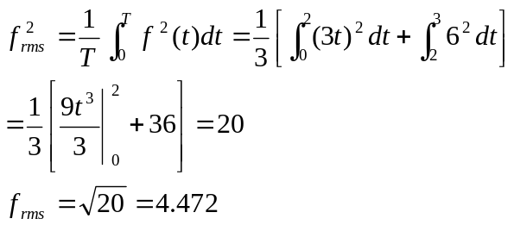

f_{rms} = 4.472

